CSP554—Big Data Technologies

Assignment #5 (Modules 05)
Exercise 1)
Create new versions of the foodratings and foodplaces files by using TestDataGen (as described in assignment #4) and copy them to HDFS
Write and execute a sequence of pig latin statements that loads the foodratings file
as a relation. Call the relation ‘food_ratings’. The load command should associate a schema with this relation where the first attribute is referred to as ‘name’ and is of type chararray, the next attributes are referred to as ‘f1’ through ‘f4’ and are of type int, and the last field is refereed to a ‘placeid’ and is also of type int.
Execute the describe command on this relation.
Provide the magic number, the load command you wrote and the output of the describe command as the result of this exercise.
Command:
Magic Number = 114914
hadoop fs -put /home/maria_dev/foodratings114914.txt /user/maria_dev
hadoop fs -put /home/maria_dev/foodplaces114914.txt /user/maria_dev
food_ratings = LOAD '/user/maria_dev/foodratings114914.txt' USING PigStorage(',') AS (name:chararray, f1:int, f2:int,f3:int, f4:int,placeid:int);

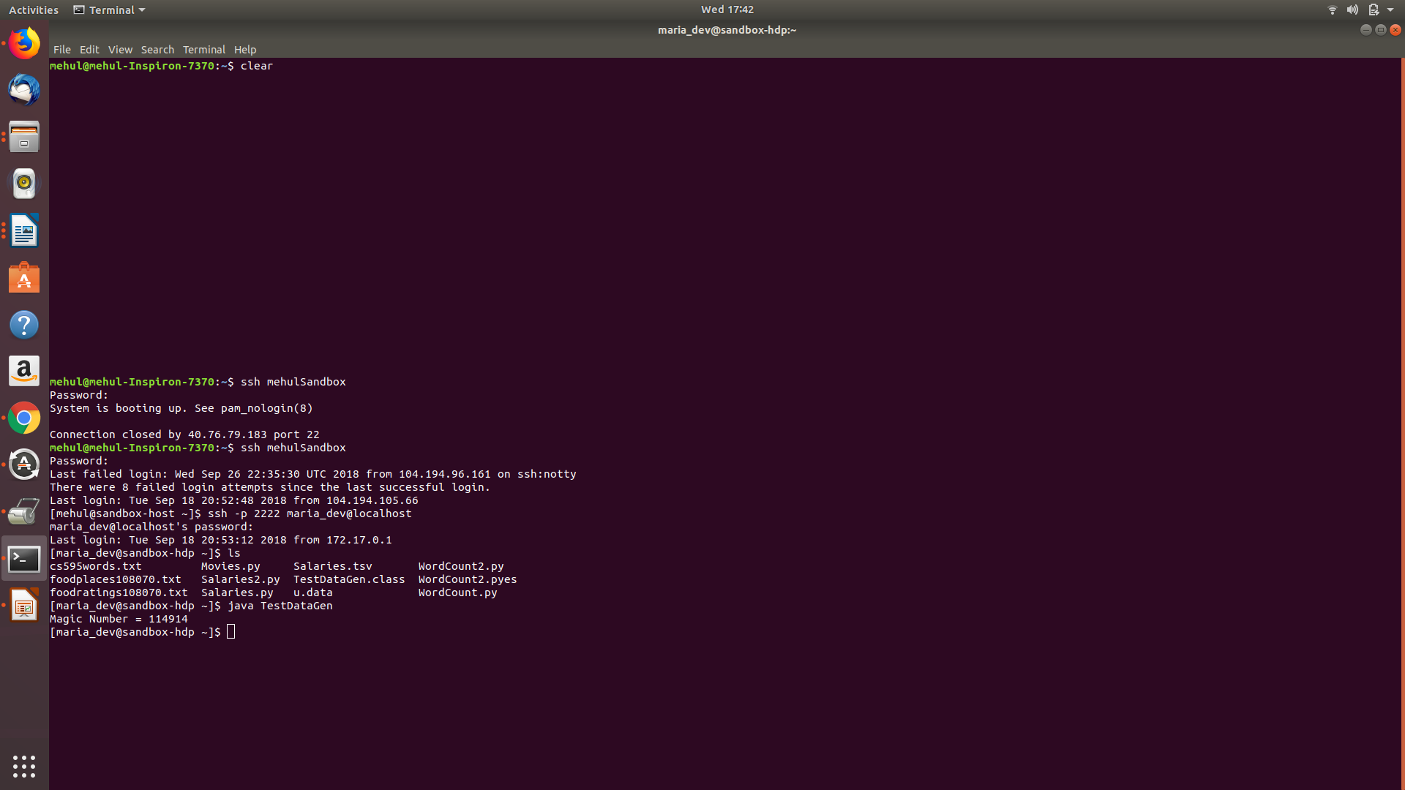
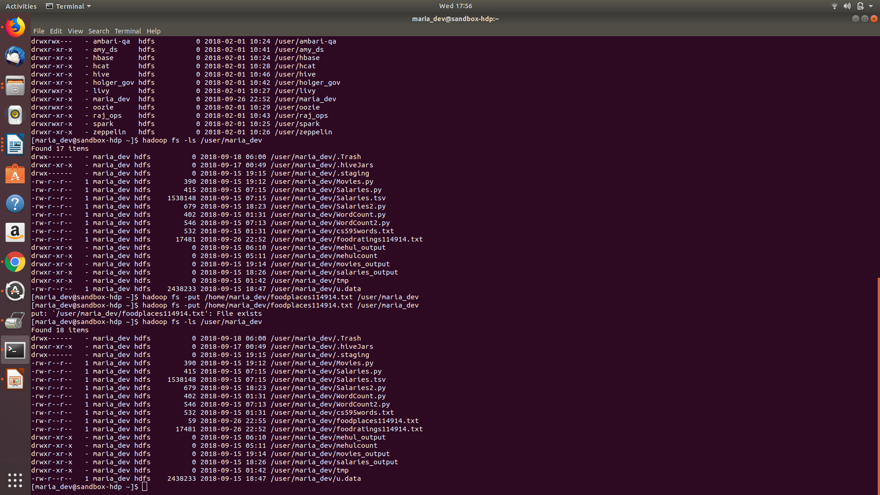

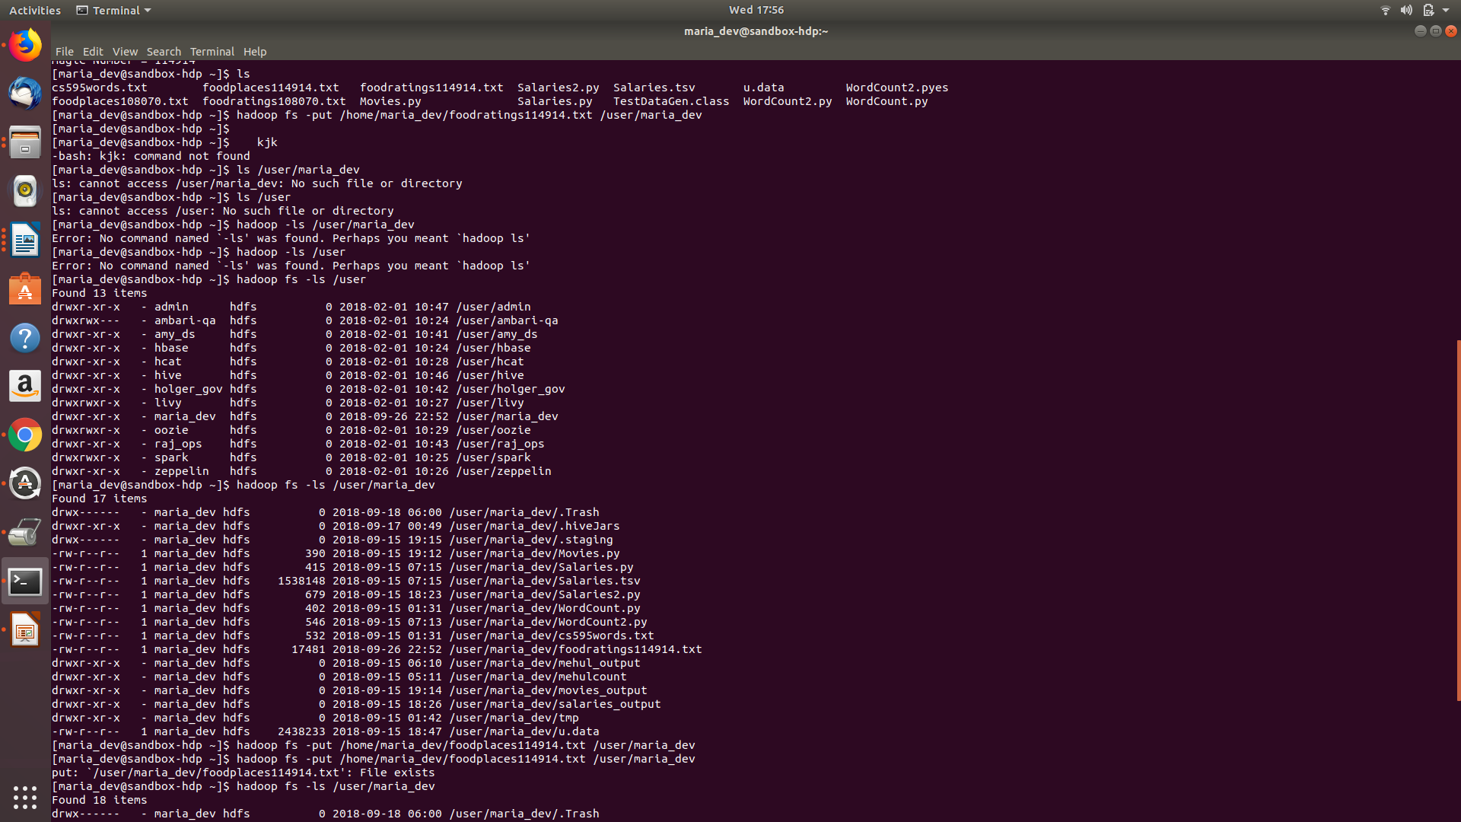

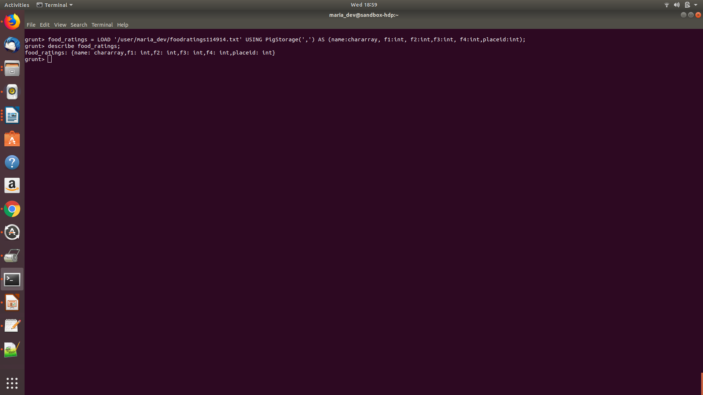
Exercise 2)
Now create another relation with two fields of the initial (food_ratings) relation: ‘name’ and ‘f4’. Call this relation ‘food_ratings_subset’.
Store this last relation back to HDFS.

Magic Number = 114914
Command:
grunt> food_ratings_subset= foreach food_ratings GENERATE name,f4;
grunt> STORE food_ratings_subset INTO 'food_ratings_subset' using PigStorage ('|');
Also write 6 records of this relation out to the console.
Submit the pig latin statements you used and the six records printed out to the console as the result of this exercise.
Command:
grunt> food_ratings_subset_6 = LIMIT food_ratings_subset 6;
grunt> DUMP food_ratings_subset_6;

Exercise 3)
Now create another relation using the initial (food_ratings) relation. Call this relation ‘food_ratings_profile’. The new relation should only have one record. This record should hold the minimum, maximum and average values for the attributes ‘f2’ and ‘f3’. (So this one record will have 6 fileds).
Write the record of this relation out to the console.

Submit the pig latin statements you used and the record printed out to the console as the result of this exercise.
Magic Number = 114914
Command :
food_ratings = LOAD '/user/maria_dev/foodratings114914.txt' USING PigStorage(',') AS (name:chararray, f1:int, f2:int,f3:int, f4:int,placeid:int);
food_rating_group_all = Group food_ratings All;
food_ratings_profile= foreach food_rating_group_all Generate(MIN(food_ratings.f2),MIN(food_ratings.f3),MAX(food_ratings.f2),MAX(food_ratings.f3),AVG(food_ratings.f2),AVG(food_ratings.f3));
dump food_ratings_profile;
Result : ((1,1,50,50,25.408,25.788))
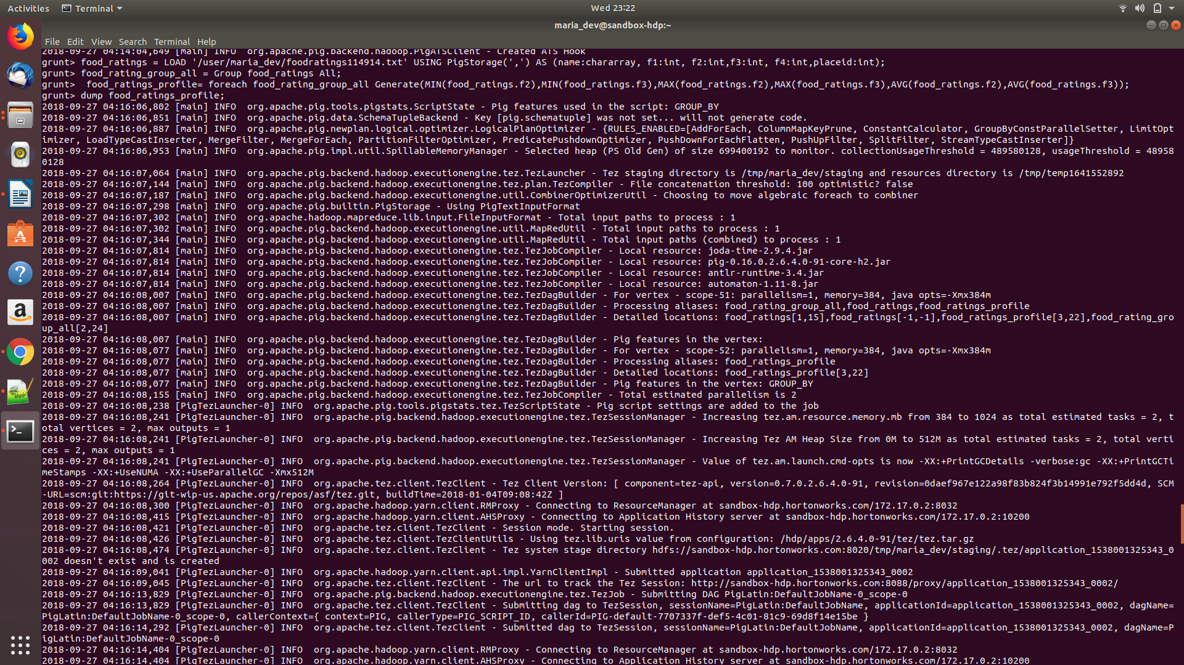

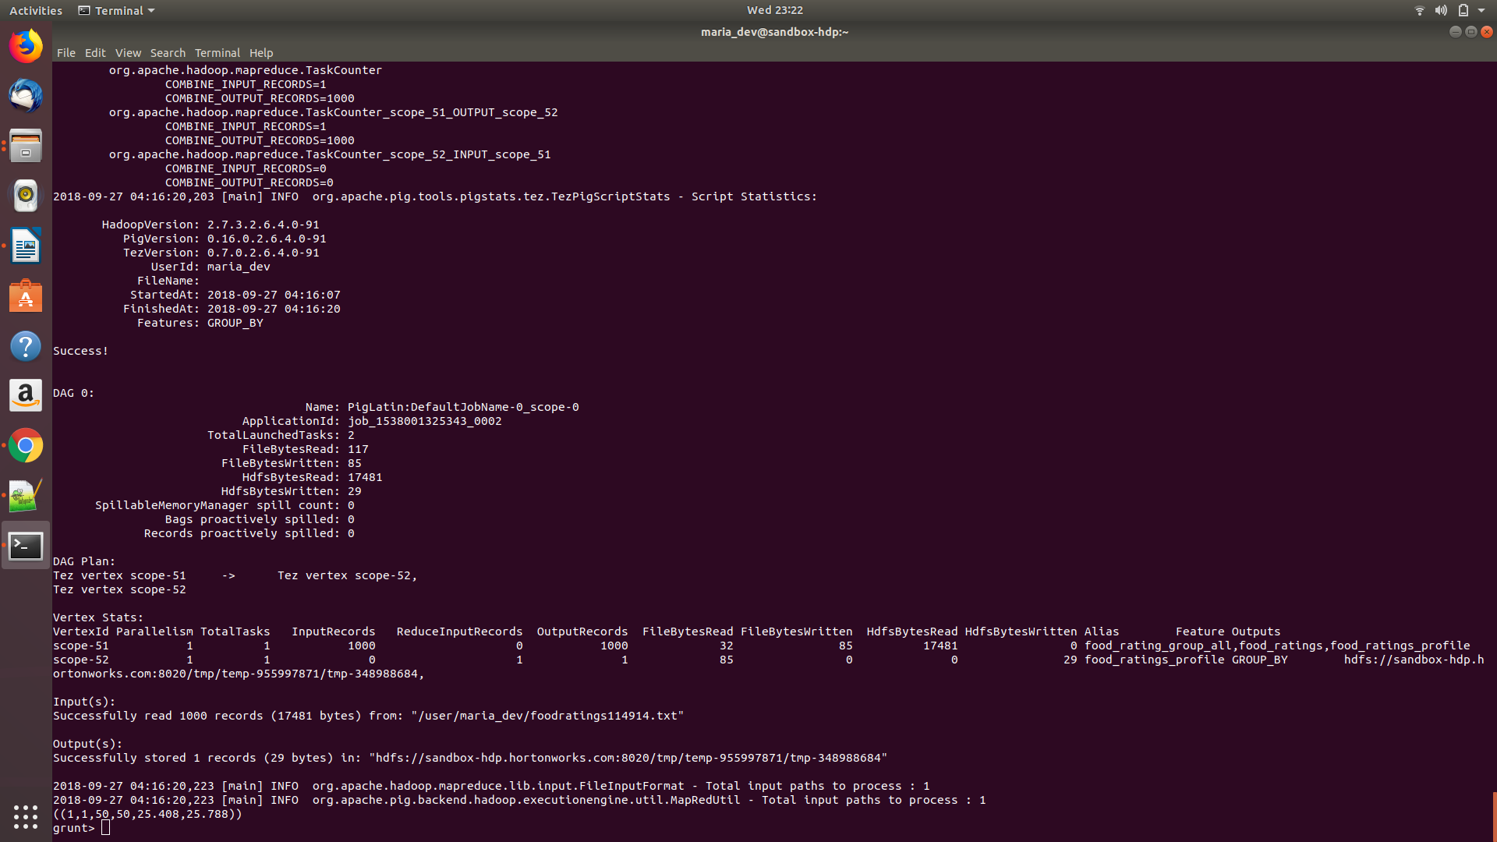

Exercise 4)
Now create yet another relation from the initial (food_ratings) relation. This new relation should only include tuples (records) where f1 < 20 and f3 > 5. Call this relation ‘food_ratings_filtered’.
Write 6 records of this relation out to the console.
Submit the pig latin statements you used and the six records printed out to the console as the result of this exercise.
Magic Number = 114914
Command :
grunt>food_ratings_filtered = FILTER food_ratings BY (f1<20) AND (f3>5);
grunt> food_rating_filtered = LIMIT food_ratings_filtered 6;
grunt> dump food_rating_filtered;
Records :
(Mel,15,28,40,29,1)
(Joe,2,38,19,22,5)
(Mel,8,14,8,19,4)
(Jill,12,18,45,22,2)
(Jill,4,20,38,48,4)
(Sam,17,28,38,20,2)
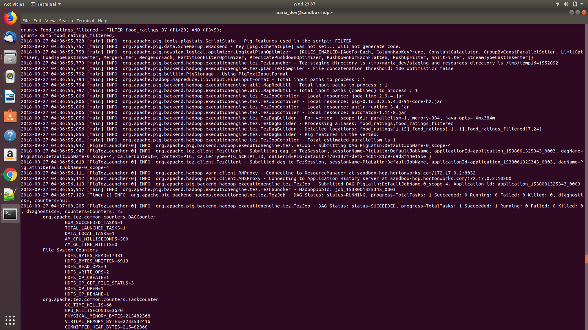
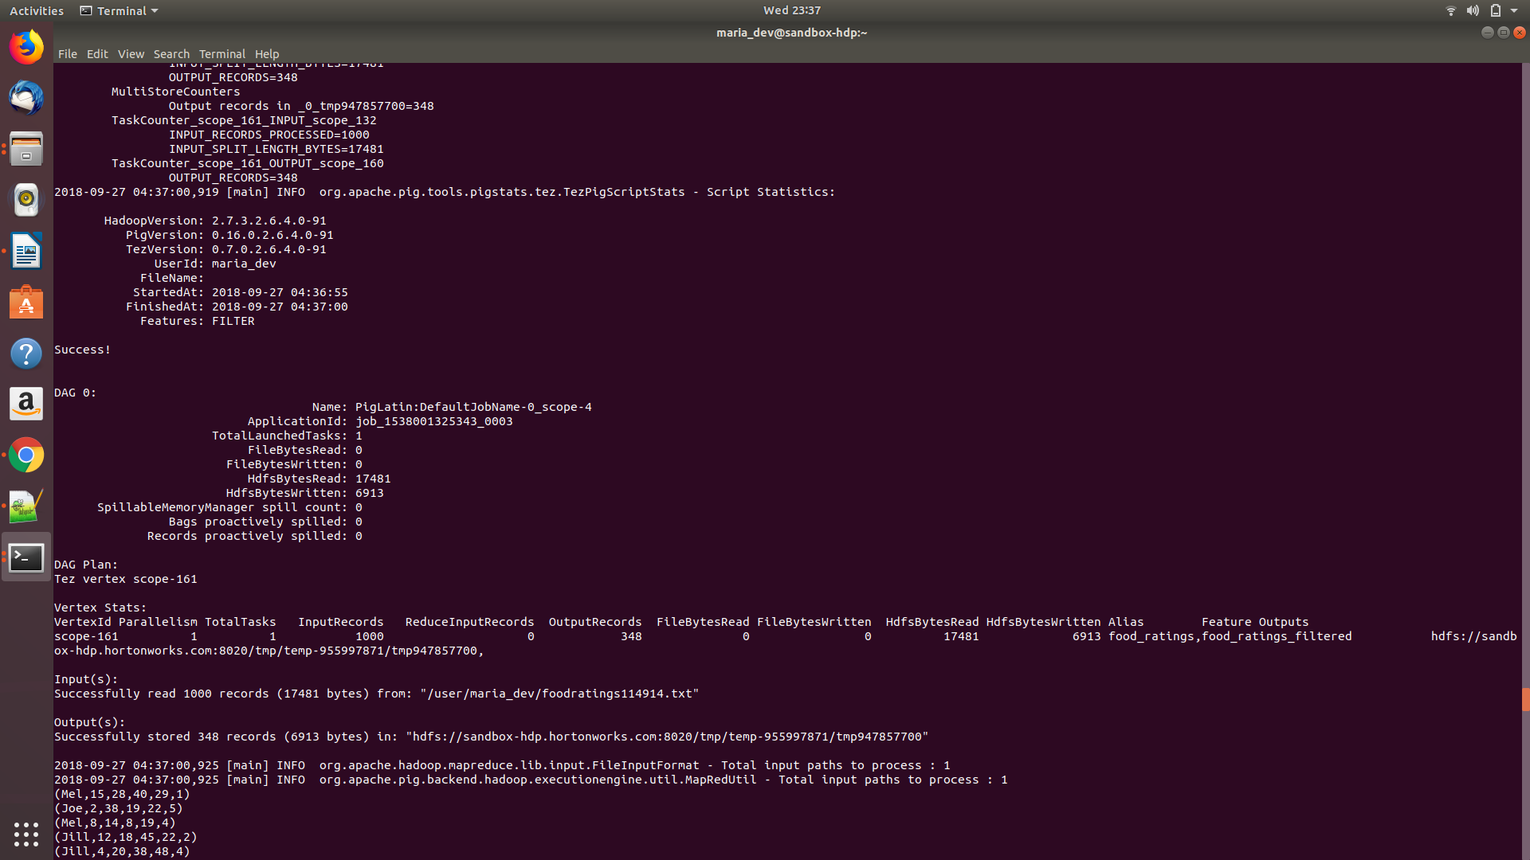

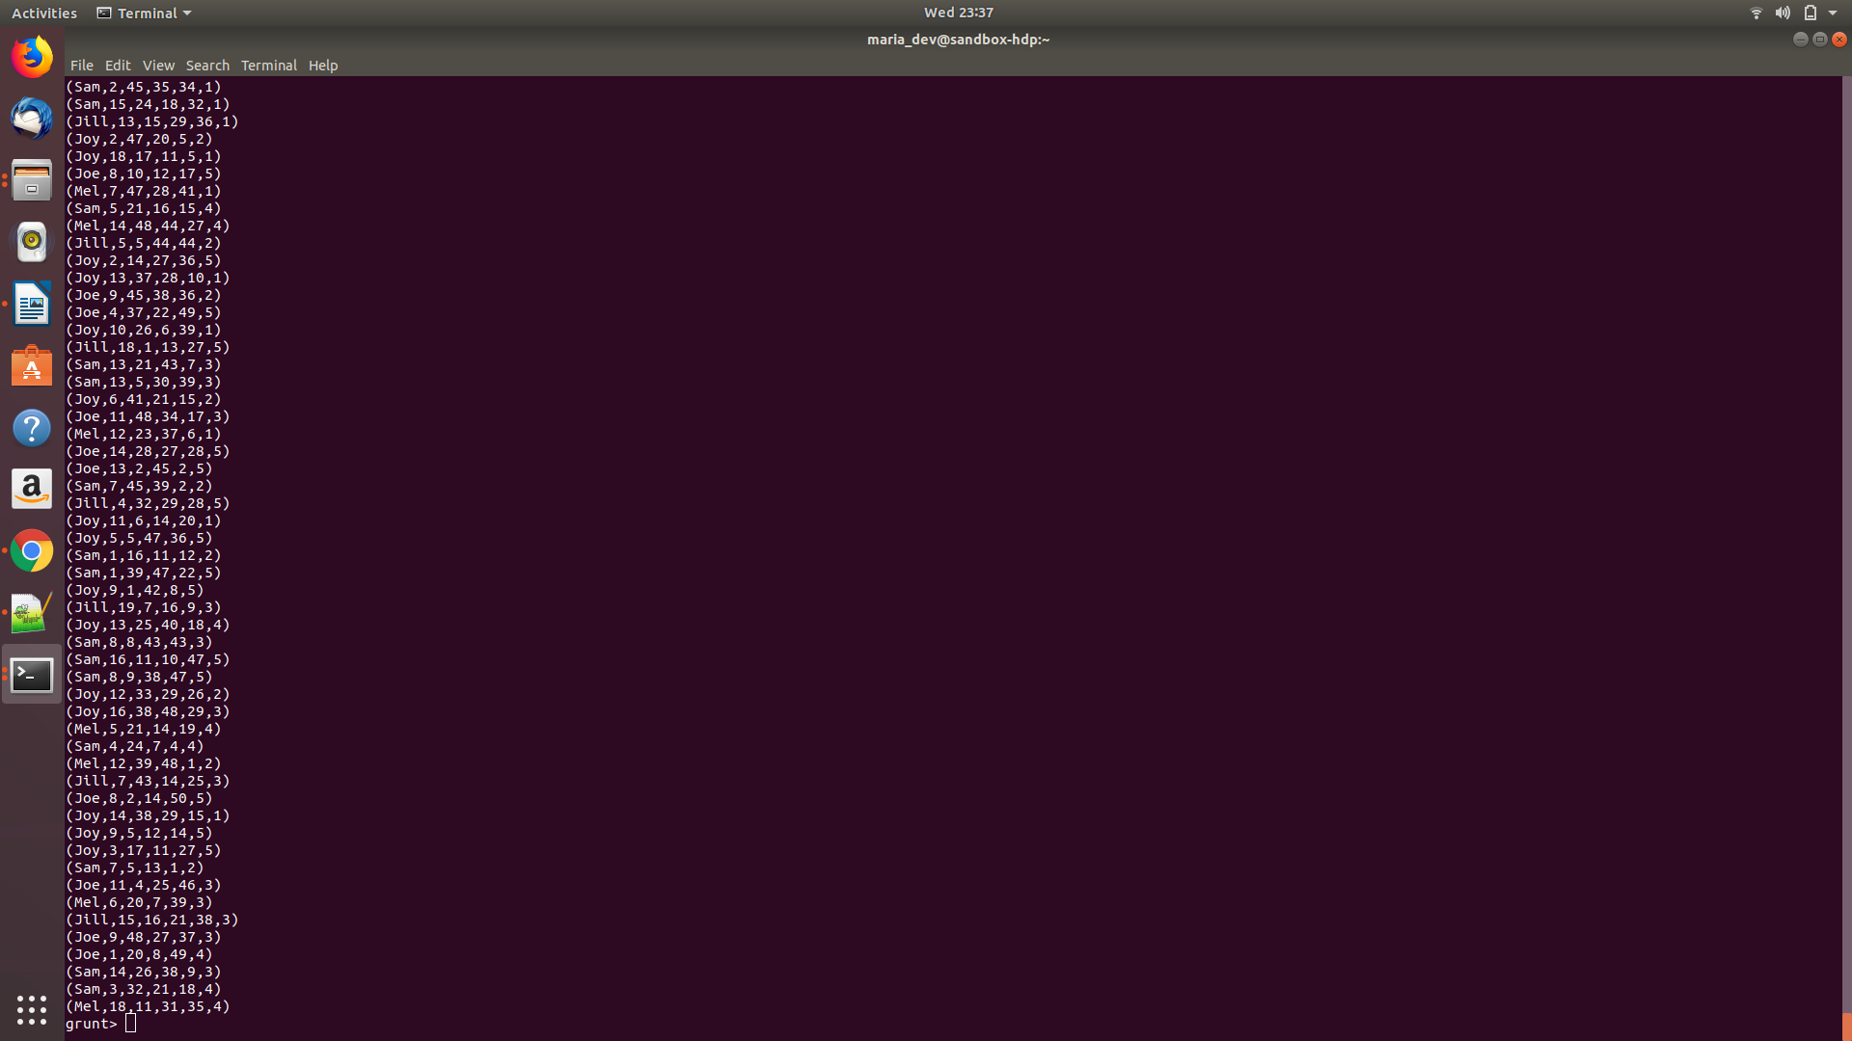
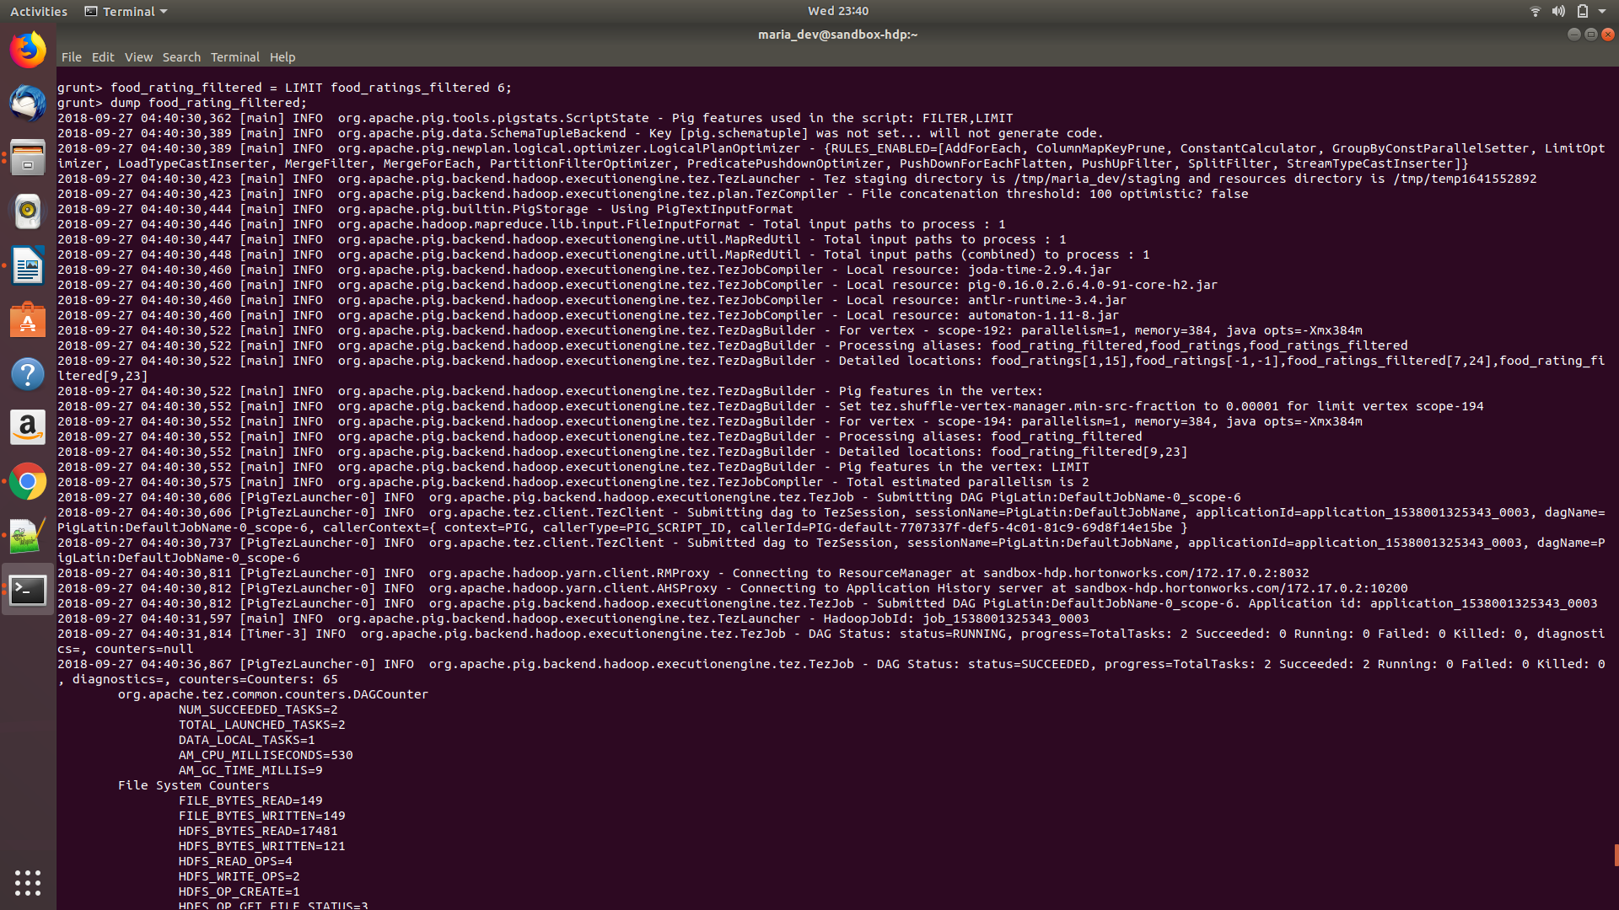

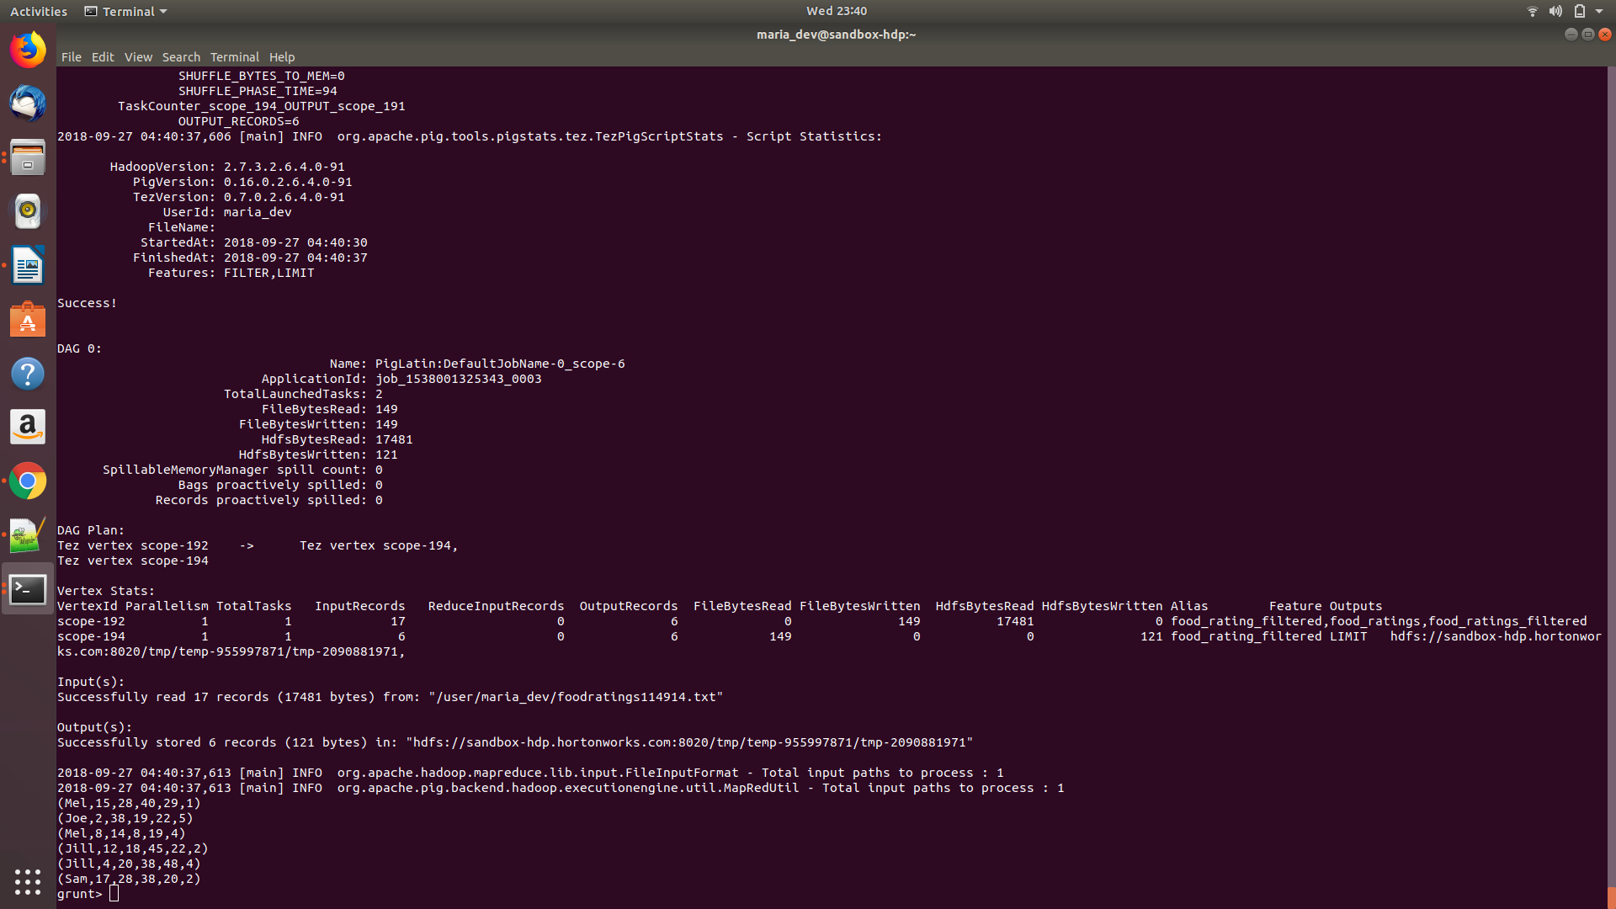
Exercise 5)
Using the initial (food_ratings) relation, write and execute a sequence of pig latin statements that creates another relation, call it ‘food_ratings_2percent’, holding a random selection of 2% of the records in the initial relation.
Write 10 of the records out to the console.
Submit the pig latin statements and the records printed out to the console.
Magic Number = 114914
Command:
grunt> food_ratings_2percent = SAMPLE food_ratings 0.02;
grunt> describe food_ratings_2percent;
food_ratings_2percent: {name: chararray,f1: int,f2: int,f3: int,f4: int,placeid: int}
grunt> food_ratings_2percent_Limit = LIMIT food_ratings_2percent 10;
grunt> dump food_ratings_2percent_Limit;
Records:
(Joy,41,45,30,13,3)
(Jill,24,38,38,16,3)
(Joy,23,37,49,45,4)
(Joy,48,11,43,40,5)
(Sam,30,29,26,32,3)
(Joe,14,8,36,26,5)
(Sam,41,40,19,26,2)
(Sam,25,43,2,50,1)
(Sam,27,19,11,48,4)
(Mel,4,44,12,19,5)
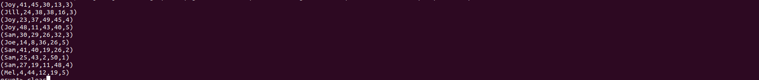

Exercise 6)
Magic Number = 114914
Write and execute a sequence of pig latin statements that loads the foodplaces file as a relation. Call the relation ‘food_places’. The load command should associate a schema with this relation where the first attribute is referred to as ‘placeid’ and is of type int and the second attribute is referred to as ‘placename’ and is of type chararray.
Execute the describe command on this relation.
Command :
grunt>food_places = LOAD '/user/maria_dev/foodplaces114914.txt' USING PigStorage(',') AS (placeid:int, placename:chararray);
grunt> describe food_places;
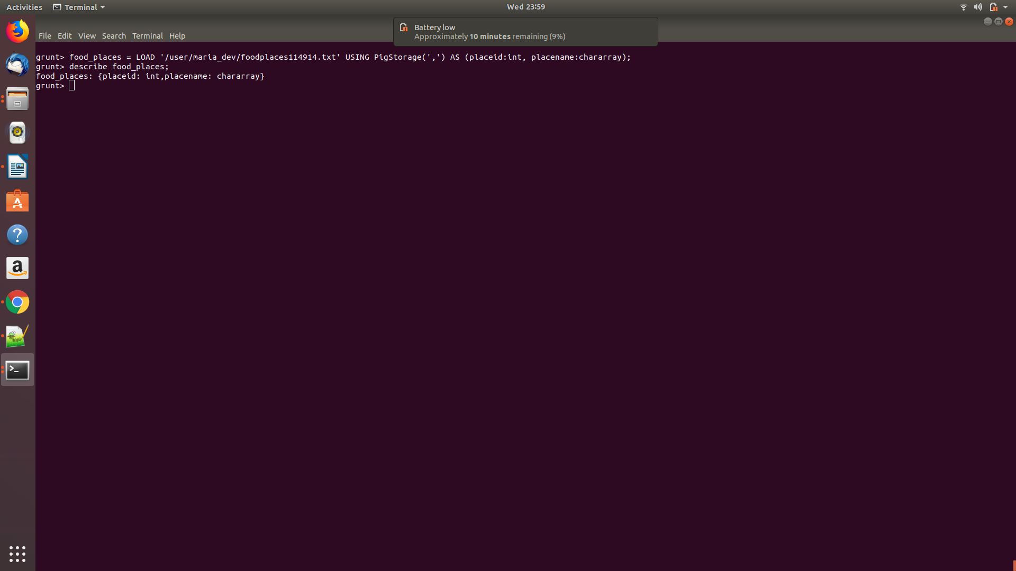
Now perform a join between the initial place_ratings relation and the food_places relation on the placeid attributes to create a new relation called ‘food_ratings_w_place_names’. This new relation should have all the attributes (columns) of both relations. The new relation will allow us to work with place ratings and place names together.
Write 6 records of this relation out to the console.
Submit the pig latin statements you used and the six records printed out to the console as the result of this exercise.
Magic Number = 114914
Command:
food_ratings_w_place_names = JOIN food_ratings BY (placeid),food_places BY (placeid);
dump food_ratings_w_place_names;
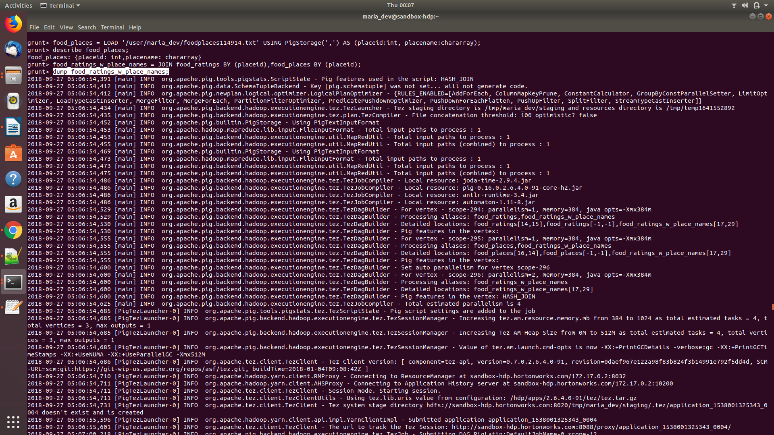
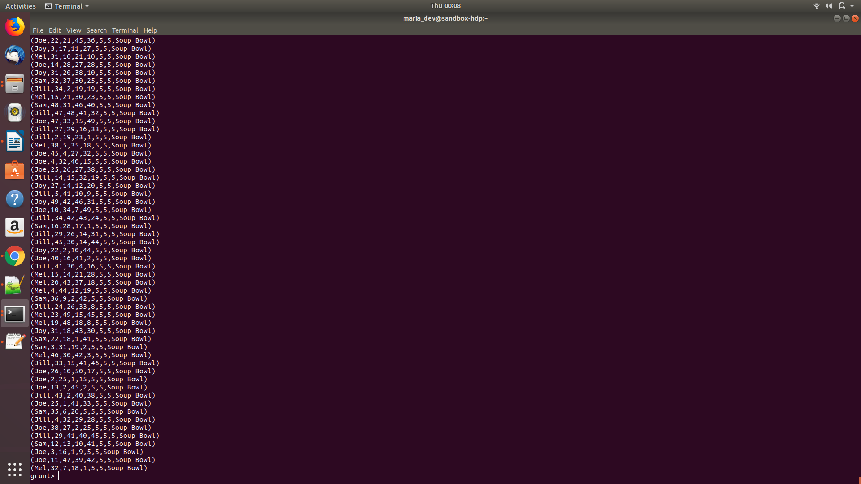

Magic Number = 114914
Command:
food_ratings_w_place_names = LIMIT food_ratings_w_place_names 6;
dump food_ratings_w_place_names;
Records:
(Mel,15,28,40,29,1,1,China Bistro)
(Joe,24,9,3,28,1,1,China Bistro)
(Joy,30,49,23,27,1,1,China Bistro)
(Mel,13,27,16,34,1,1,China Bistro)
(Mel,14,24,26,2,1,1,China Bistro)
(Sam,50,8,34,27,1,1,China Bistro)

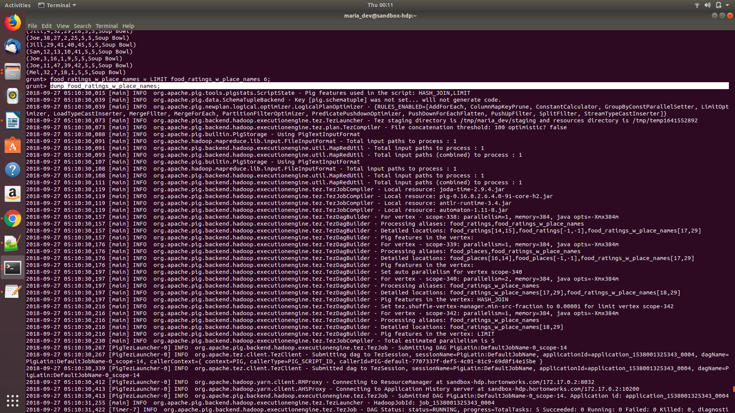
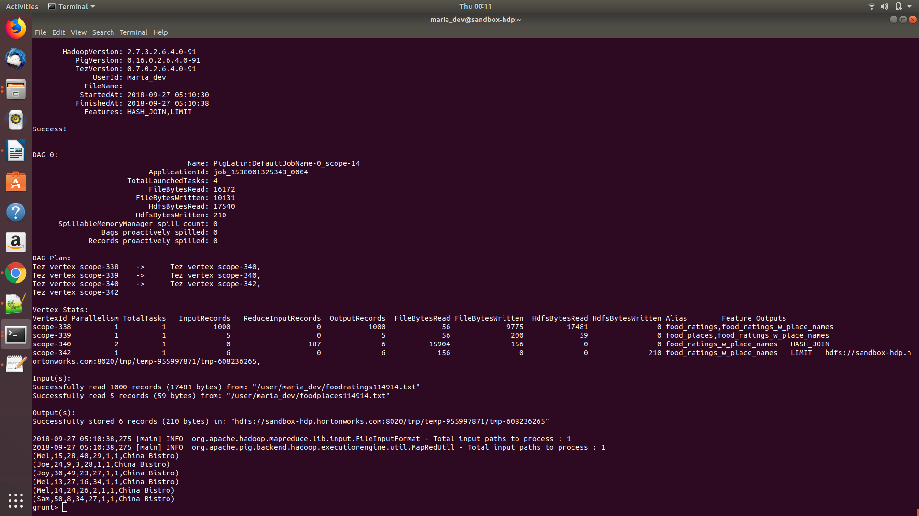

Extra Credit
Read the article about Spark available on the blackboard in the ‘Articles’ section:
“Resilient Distributed Datasets: A Fault-Tolerant Abstraction for In-Memory Cluster Computing”
Provide a half-page summary and include some of your own comments.
The article describes Resilient Distributed Datasets (RDDs), a distributed memory abstraction method.RDD mainly focuses on two type of application that other frameworks handle in efficiently.theye are iterative algorithm and interactive data mining tool.RDD are fault tolerant,parallel data structures that enables efficient data reuse..Spark exposes RDDs through an API which is similar to DryadLINQ. It provides coarse-grained transformation that restricts application from bulk write.In RDD,only lost patitions need to be recomputed.It also has immutable nature.However,RDDs would be less suitable for applications that make asynchronous fine-grained updates to shared state.RDD can be used in application having Logistic Regression and Pagerank present in its implementation.Spark provides three way for storing persistant RDDs i.e. in-memory as deserialized java object,in-memory storage as serialized data and on-disk storage.Way of storage depend on the amount of data and frequency at which it has to be acessed.After comparing Spark and RDD with other machine learning applications,Spark came out to be faster that other applications like Hadoop and HadoopBinMem.Various user application like In-memory Analytics,Traffic Modelling,Twitter Spam Classification and Interactive Data Mining are built with Spark.Development of Spark debugger is in-progress.

